Bootstrap 5 Forms

## **Stacked Form**

All textual <input> and  <textarea> elements with class .form-control get proper form styling:

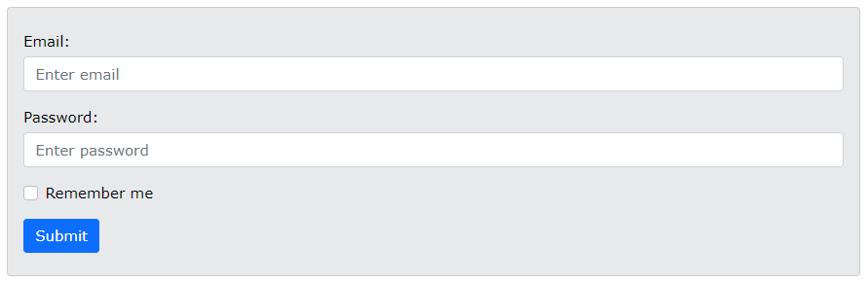

### **Example**

<form action="/action_page.php">  
  <div class="mb-3 mt-3">  
    <label for="email" class="form-label">Email:</label>  
    <input type="email" class="form-control" id="email" placeholder="Enter email" name="email">  
  </div>  
  <div class="mb-3">  
    <label for="pwd" class="form-label">Password:</label>  
    <input type="password" class="form-control" id="pwd" placeholder="Enter password" name="pswd">  
  </div>  
  <div class="form-check mb-3">  
    <label class="form-check-label">  
      <input class="form-check-input" type="checkbox" name="remember"> Remember me  
    </label>  
  </div>  
  <button type="submit" class="btn btn-primary">Submit</button>  
</form>

Also note that we add a .form-label class to each label element to ensure correct padding.

Checkboxes have different markup. They are wrapped around a container element with .form-check, and labels have a class of .form-check-label, while checkboxes and radio buttons use .form-check-input.

## **Form Row/Grid (Inline Forms)**

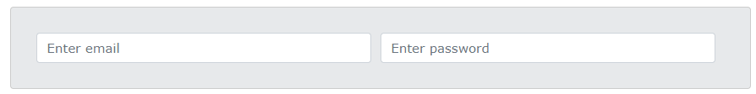If you want your form elements to appear side by side, use .row and .col:

### **Example**

<form>  
  <div class="row">  
    <div class="col">  
      <input type="text" class="form-control" placeholder="Enter email" name="email">  
    </div>  
    <div class="col">  
      <input type="password" class="form-control" placeholder="Enter password" name="pswd">  
    </div>  
  </div>  
</form>

For more information [clickhere](https://www.w3schools.com/bootstrap5/bootstrap_forms.php)

References

https://www.w3schools.com/bootstrap5/bootstrap_forms.php